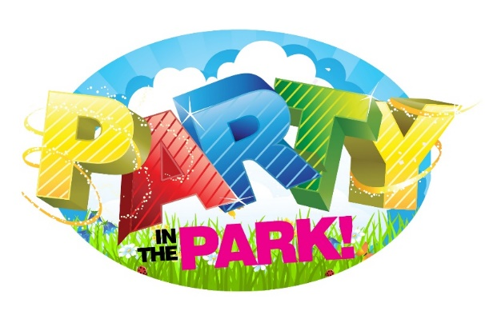

Press Release
May, 2023
“Party in The Park” in the Village of New York Mills

New York Mills is dedicated to making its community a great place to live, work, play, and conduct business. The Mayor, Ernie Talerico, and The Parks and Recreation Committee are proud to announce a village wide family fun celebration called “Party in The Park.” It will be held on Saturday, July 8th, at Pulaski Park on Main Street, from 5 pm to dusk.
The Village of New York Mills wants to celebrate with our amazing community with a variety of food trucks both adult and kid friendly, music throughout the evening with DJ and live acoustic music performed by Philip Arcuri Jr., cornhole tournaments with professional ACA boards and scoreboards Hosted by Toss Like A Boss CNY Cornhole, no experience needed and all skill levels welcome. (*Registration begins at 5pm and prizes will be awarded for the top 3 finishers at the end of the night.) In addition, there will be face painting, and activities sponsored by Christine Jarvis of State Farm for all to enjoy. Feel free to bring your lawn chairs so you may sit, relax, and enjoy dinner and the amazing entertainment of the evening.
In conjunction with the Village wide garage sales this day, Crafters will be showcasing their talents for purchase starting at 10:00am and will be available throughout the “Party in The Park.”
To top the evening off, an amazing display of fireworks will end the night of friendship and celebration for the Village of New York Mills.

