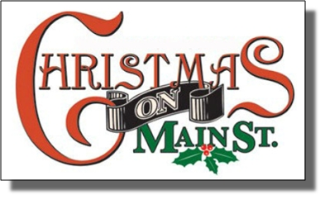
Come Spend a Fun Filled Holiday Evening with Us

On Friday December 10th our Annual Christmas on Main Street will take place. It has been said that our Christmas on Main Street shows a sense of community, energy and holiday spirit.

Schedule of Events: (Tentative - Subject to change)
6:00 PM - The Christmas Bonfire will be lit.
6:15 PM - Parade of Lights (Lighted Fire Trucks from local communities)
6:30 PM - Lighting of the Village Christmas Tree - New York Mills Optimist Club
7:00 PM - Optimist Club Chili Contest under the pavilion.
$100.00 prize to be awarded to the chili voted the best.

Santa and Mrs. Claus arrive by Fire Engine at the pavilion, at the conclusion of the parade.

6:30 PM - NYM High School Choir performs around the fire.
6:15 PM -
5 PM-7PM—Hay ride will be running continuously through the village.

∗ This year we will be focusing on the needs of the veterans, we will be collecting non-perishable food items for our veterans which will to help to provide meals and supplies for the many, less fortunate veterans in our area.

Throughout the entire evening, several other events will be taking place:
∗ The Optimist Club will be conducting their free chili contest under the pavilion

∗ New York Mills Fire Dept. will be offering free popcorn and cocoa and will be monitoring the bonfire.

∗ New York Mills Fire Dept. Ladies Auxiliary will be handing out Christmas Items.

∗ We wish to thank all of the individuals, organizations and the Village of New York Mills who help make this event possible, along with Mr. Fred Griffiths for providing our sound system.

As a special addition to our celebration, our Special Santa Mailbox will be out near the Gazebo from December 5th thru Christmas on Main Street on the 10th. So get your letters ready early and get them in the box before the end of the evening. We are certain Santa himself will answer each and every letter! The mailbox will be placed at the Pulaski Park right near the gazebo on December 5th. Just look for the giant blow up Santa !

